**Subject : EIE2108 Lab 1 Report**

**Student ID: 19069748D**

**Name: Kwok Kevin**

Details of Lab 1:

During the lab activity, students’ mission is creating a class named Quaternion, which can handle quaternion algebras.

An instance of the class is a quaternion (= a+ b**i** + c**j**+ d**k**) in a form of list [a, b, c, d]. There are 5 methods in the definition of students’ class: Add(), Mul(), Conj(), Inv() and Norm(). Those functions through the class will be used to make the 5 aforementioned operations respectively.

While students finish the defining of the class, they are required to provide 3 set of non-zero quaternion objects ((z1, z2 and z3 ). Base on these 3 set of non-zero quaternion objects, there are 6 computations to compete:

1. 
2.  
3. 
4. 
5. 
6. 

Background:

In mathematics, the quaternions are a number system that extends the complex numbers. Quaternions are generally represented in the form:

a + b**i** + c**j** + d**k**

where a, b, c, and d are real numbers, and i, j, and k are the fundamental quaternion units. The product of 2 fundamental quaternion units has the following properties:

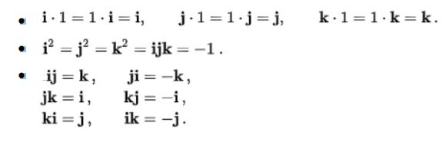

Table 1 summaries the products of different fundamental quaternion units. Some basic algebra operations of quaternions are listed as follows:

Background:(Con’t)

Some basic algebra operations of quaternions are listed as follows:

Analysis and implementation of Codes:

First of all, I have to create a class and the following function to make people enter the correct format of quaternion objects

Second, there are 5 function to be created to realize the 5 aforementioned operations respectively, which are Add(), Mul(), Conj(), Inv() and Norm()

For definition of the Add():

For definition of the Mul():

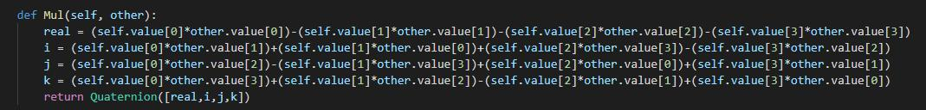

For definition of the Conj():



For definition of the Inv():

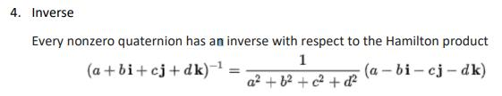

For definition of the Norm():

After setting up the functions mentioned above:

I would set 3 non-zero quaternion objects

Z1 = 1-2i+3j-4k

Z2 = 5-6i+7j-8k

Z3 = -9+11i-16j+9k

And then print 3 of them out

The leaving mission do the 6 tasks with these 3 zx number sets

For 1.

Since we have defined the multiplication function. With completing task 1, just simply take the value with command that we built up in the class and print it out like above.

For 2. 

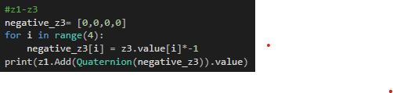

Since we only build the quaternion with it but not subtraction. We have make the z3 number set become negative with the for loop to make all z3 number become negative side. Then add them z1 and negative z3 to fulfill task 2.

For 3.

Similar to task 1, just z1 have to work with conjugate before the multiplication with z3.

For task 4.

We have to do z3 with the index -3 and -3 = -1 * 3

So we can understand the task 4 as inverse of z3 takes 3 times multiplication of itself. Therefore, there are :  
 z3 inverse * z3 inverse * z3 inverse

shown above

For task 5.

Since we have defined the norm function to take the root of square of object. It directly complete what task 5 works, just simply take the z2 number set with command that we built up in the class and print it out like above.

For task 6.

This task 6 is a final boss that fusion from task 1 to task 5.

Since there are all elements required though the functions we have built before.

The first step to complete this task 6.

We have to define the value of the element in this task

Like z1^3,conjugate of z2, z3^-4 , (z1+z3)^2, ||z2|| and (z1+z2)

For z1^3, we have to do the multiplication 2 time of itself.

For conjugate of z2, take the class function command -conj with z2.

For z3^-4, like task 4, multiplicate with inversed it 4 times.

For (z1+z3), we take the addition with z1 and z3, the square will take it later.

For ||z2||, similar to task 5,dricetly do the command that the function we build up before in the class.

For (z1+z2), like z1+ z3, just do the addition with function add in class.

Then we take the dividend and divisor with the correct elements.

Dividend will be

Divisor will be 

The for loop is to complete the divisor multiplicate between norm.z2 and (z1+z2).

And the make the task works.

This is the outcome of the program.

